Session 3:

- Write an SQL query to select all restaurants from a table named 'restaurants' where the rating is greater than or equal to 4.5.


- In a table called 'movies', filter and display only the movies released after 2020 and with genre 'Action' using the WHERE clause and AND operator.
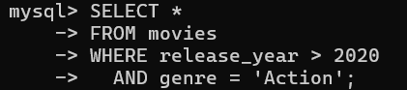

- Given a table 'products' with columns (id, name, price, category), write a query to find all products not in the 'Electronics' category or with a price less than 500.
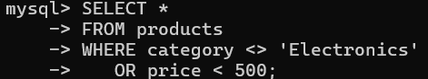

- Write an SQL query for a table 'users' to show all users who are NOT from 'Ahmedabad' and have more than 1000 followers.<br><br><em><strong>Hint:</strong> Use the NOT operator combined with AND.</em>
